**MUHAMMAD HANIFF BIN NGAZUDDIN**

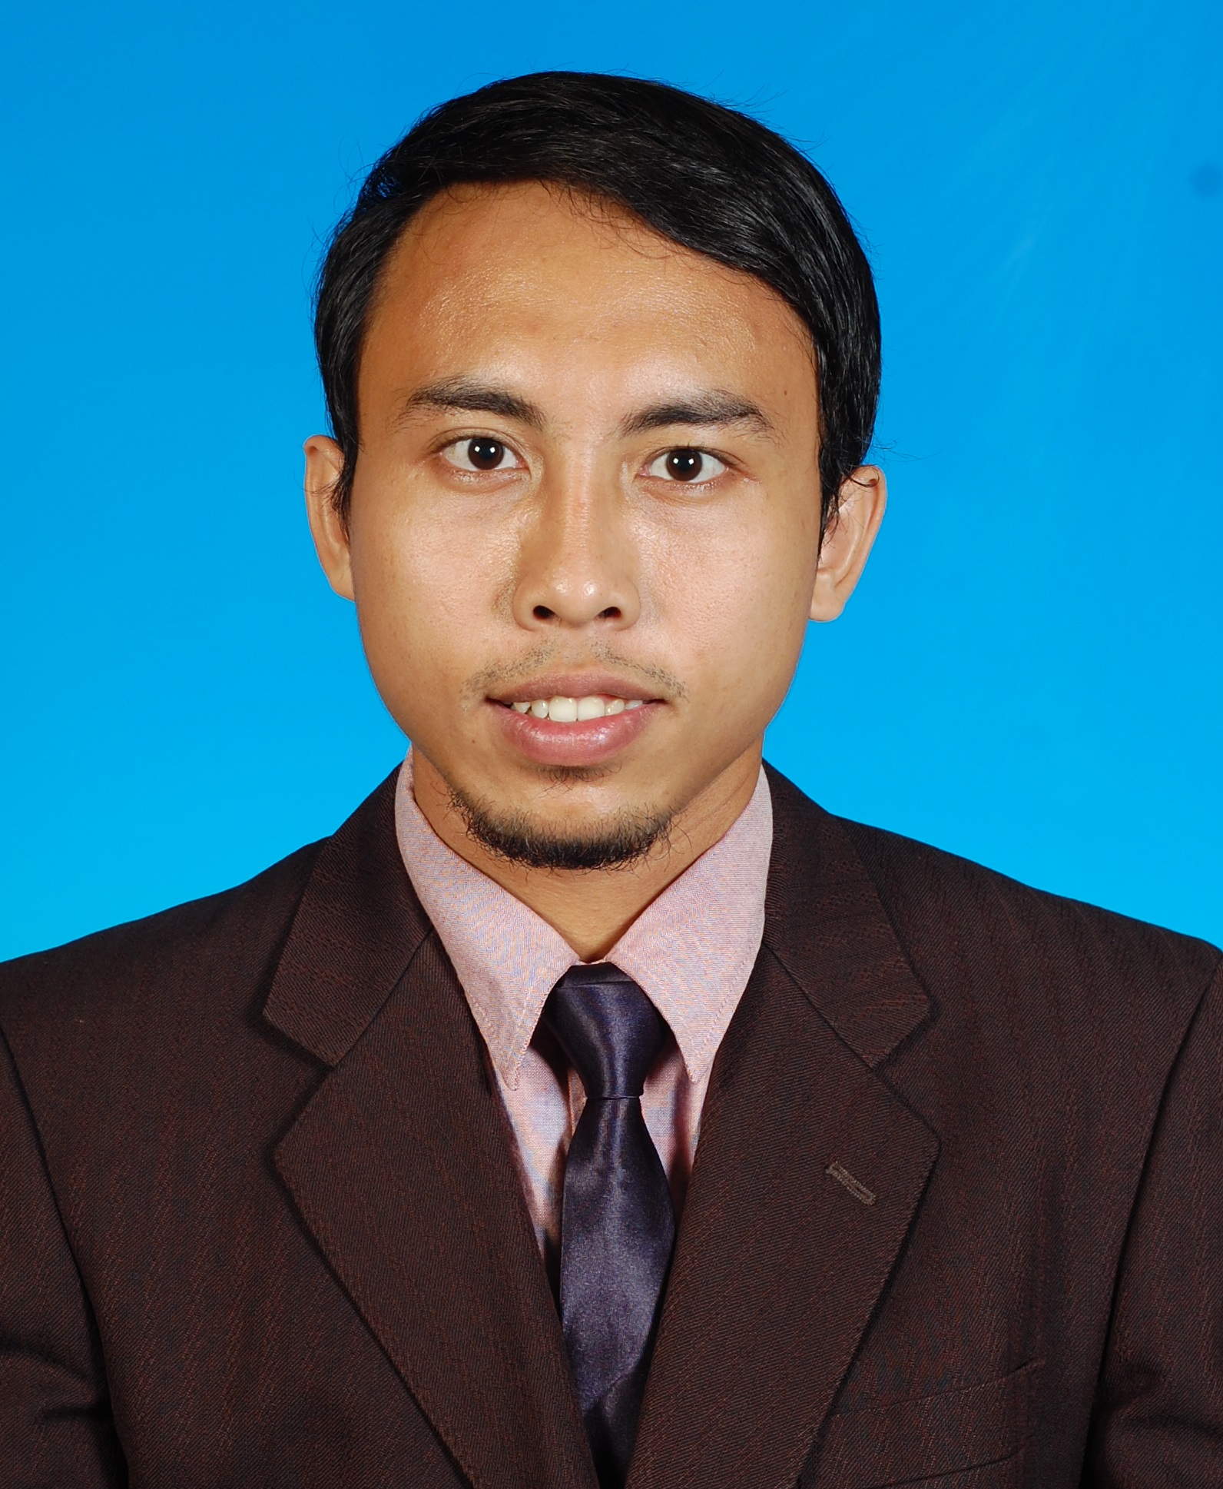

Address : No.13, Jalan Bunga Kekwa,Taman Pertama,

45200 Sabak Bernam, Selangor

Contact No. : 013 3098934

Status : Married

E-mail : [haniffngazuddin2803@gmail.com](mailto:haniffngazuddin2803@gmail.com)

Expected salary: RM 2600 (Negotiable)

**__________________________________________________________________________________**

**OBJECTIVE :**

Seeking a challenging opportunity that will benefit my basic skills and knowledge in electrical engineering and improve my ability to work well with people which will allow me to grow personally, financially and professionally.

**ACADEMIC BACKGROUND:**

|  |  |
| --- | --- |
| **University Tun Hussein Onn (UTHM)** Batu Pahat, Johor | * ***Bachelor of Electronic Engineering with Honor*** * (S.Y 2013 – 2016) * Subject taken: * Data Communication * System Communication * Signal and System * Engineering Management * Optical Communication * Final Year Project (Fiber Optic) * Grade : 2.47 |
| **University Technology Malaysia (UTM)** *),* Jalan Semarak, Kuala Lumpur | * ***Diploma in Electrical Engineering (Communication)*** * (S.Y 2009 – 2012) * Subject taken: * Instrumentation and Calibration * Electric Circuit * PLC * Microprocessor * Engineering Management * Optic Communication * Grade : 2.63 |
| **Technical Institute of Kuala Lumpur (TIKL)** | * ***Electrical Engineering*** * (S.Y 2007 – 2008) |

**WORK EXPERIENCES:**

|  |  |
| --- | --- |
| **Karuning Jati Enterprise (Internship)**  (S.Y 2014 – 2015) | * Technician (wiring) * Involve in wiring * Involve in maintenance of air conditioner |
| **Aimas Enterprise**  (S.Y 2016 – 2016) | * Site supervisor * Monitor and supervise workers * Organise team of technical and quality * Check, survey and monitor the project so that the quality produced will be satisfying * Make sure the project meet the deadline given |

**SKILLS:**

|  |  |
| --- | --- |
| Language (Speaking and Writing) | * Fluency in Bahasa Melayu * Moderately fluence in English |
| Communication | * Comfortable writing and speaking |
| Computer Literacy | * Proficient at MS Word and MS Power Point. * Proteus * CST Simulation Software * Optisystem Simulation Software * Matlab |
| Others | * Basic wiring * Simple soldering |

**JOB PREFERENCES:**

* Type of employment : Full Time
* Willing to travels : Yes